**Cubanops architecture**

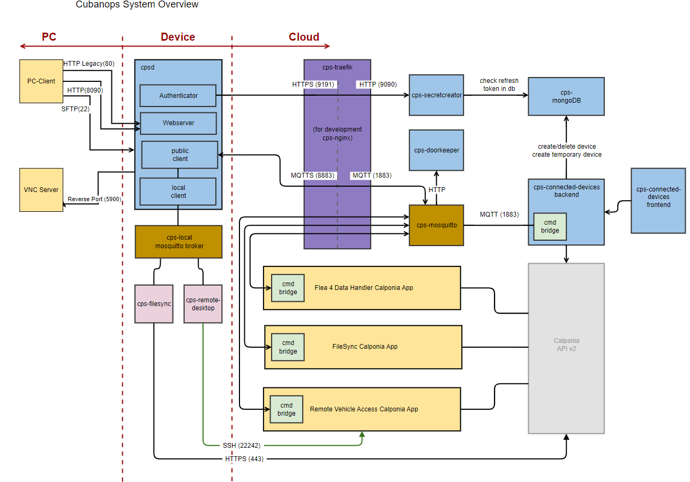

File transfer between PC and cloud , cloud and pc occurs through device.

Authentication – HTTPS

Communication between device and cloud- MQTT protocol

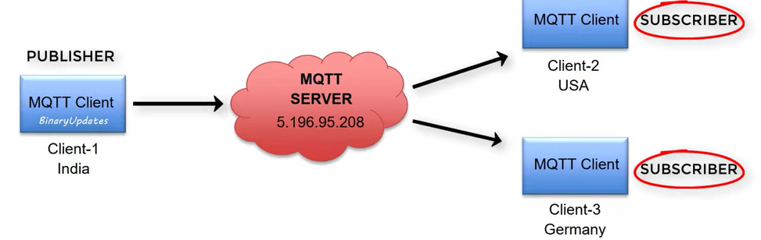

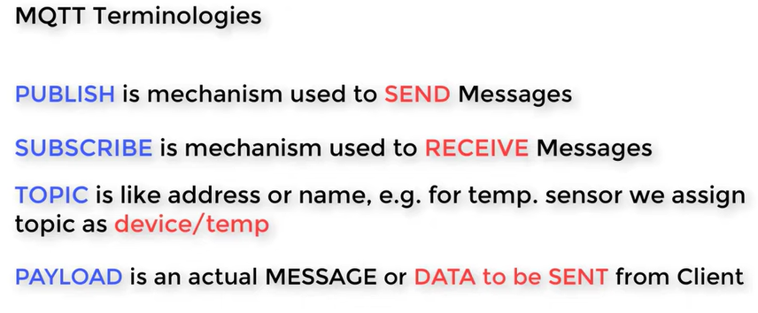

Token generation while authentication – cps secretcreator

Data stored in database- MongoDB

Calponia provides features for the apps

Device management - onboarding, device status, pinging the device, editing the ip address etc

**Connected devices folder**

* **Device and cloud**

**DEVICE**

Mosquitto

Dockerfiles

**Cpsd -> src =>**

* authentication (c++)
* Communication
* Configuration
* Devicestatus
* Topic
* Subscriptions

**CPS agents => cps_device_settings=>src**

* Configuration (py)
* Cps_device_settings
* Cps_getsignal_strength_with_ping
* Cps_set_device_ip

**Cps_device_webserver**

* Cps_car pc_status (py)
* Cps_device_webserver

**CLOUD**

**Backend: src=> (ts)**

Lib, middleware, services, routes

**Deployment:** Docker , Kubernetes

**Doorkeeper: src=>config=>**

Mqtt, http

**Frontend: (react+typescript)**

Action Button

DeviceTable

DeviceTableFilter

Navbar

**Mongodb**

**Createuser : user, password, role**

**Secretcreator: config=>** http.ts, mqtt.ts

**Lib=>** addtokentoclient.ts

Createtoken.ts

**Router=>** accesstoken.ts

Refreshtoken.ts

**Solutions**

* Filesync (calponia, device)
* Flea4
* RVA

Open points.

1. Door keeper?
2. Why do we generate token?
3. Diff b/w Access token & refresh token ?
4. Docker files in multiple folder?
5. Docker and Kubernetes are used for containerization , But why both are used here?
6. Database why mongodb preferred for our project?
7. Test and src folder same files. Why we have test folder?
8. Does mqtt communication take place all the time?
9. Device – calponia equipment ?